Table of Contents
1. Introduction 2
1.1 Purpose 2
1.2 Scope 2
1.3 References 2
1.4 Overview of this document 2
2. Project Overview 3
2.1 Project Purpose, Scope, and Objectives 3
2.2 Assumptions and Constraints 3
3. Project Organization 4
3.1 Organizational Structure: 4
3.2 Roles and Responsibilities 4
Table A: Roles and Responsibilities 5
3.3 External Interfaces 5
4. Management Process 5
4.1 Project Estimates 5
4.2 Release Plan 6
4.2.1 Gantt chart 6
4.2.2 Releases 6
4.2.3 Project Schedule 7
4.2.4 Iteration Plans 7
4.3 Team Member’s Training 8
4.4 Project Monitoring and Control 9
4.4.1 Requirement Management 9
4.4.2 Schedule Control Plan 9
4.4.3 Quality Control Plan 9
4.4.4 Reporting Plan 9
4.4.5 Risk Management Plan 9
4.4.6 Configuration Management 9
4.4.7 Communication channels 9
5. Technical Process Plans 10
5.1 Software Development Lifecycle 10
5.2 Software Design 10
5.3 Software Development 10
5.4 Software Unit Testing 10
5.5 Review Process 11
5.6 Software Integration 11
5.7 Software Deployment 11
5.8 Project documentation 11

Software Development Plan

Introduction

Purpose
The purpose of this document is to define the activities in terms of the development strategy, project and product characteristics, and task schedule for the release, task resource requirements, dependencies as well as resource costs and staffing requirements for the lifetime of a release. The document communicates project plans to program and line managers and serves as a guiding document for project tracking and oversight.

Scope
This software development plan describes the overall plan to be used by the team for developing the My Apartment Booking. The details of the individual iterations will be described in the iteration plans. The plans as outlined in this document are based upon the software requirement as defined in the SRS document.

References
For the software development plan, the list of the referenced artifacts includes:

- Project Management Plan
- Requirements Specification document
- Risk Management Plan
- Configuration Management Plan
- Quality Assurance Plan
- Design document
- Programming Guidelines

Overview of this document
This software development plan contains the following information:
- Project Overview: The project overview provides a description of the project’s purpose, scope and the objectives. It will also define the deliverables that the project is expected to deliver.
- Project Organization: This section will define the organizational structure of the project team
- Management Process: This section will explain the estimated schedule, defines the major phases and milestones for the project, and describes how the project will be monitored.
- Technical Process Plans: This section will provide an overview of the software development process, including methods, tools and techniques to be followed.
- Supporting Process Plan: This section will include the configuration management plan.

Project Overview

Project Purpose, Scope, and Objectives
My Apartment Booking will be a web based application and booking engine that will provide 24/7 real time live online availability for all our apartments so you never have to put your plans on hold. It have admin site as well as client site. Following are the main modules of system:
- Administration
- Booking Management
- Online Payment
- Reports

Assumptions and Constraints
- GitHub is used for source control and document versioning.
- Telerik controls will be used for application development.
2.4 Evolution of the software development plan
The Software development plan will be revised prior to the start of each iteration phase as per project plan.

Project Organization

Organizational Structure:

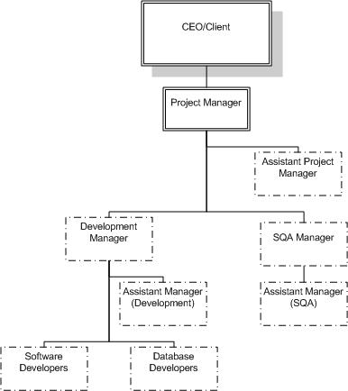

Figure 1: Organizational Structure

Roles and Responsibilities
The roles and responsibilities are defined and assigned to team members as follows. One person may fulfill more than one role.

Role | Responsibilities | Assigned To
Client/CEO | - Monitors implementation of each phase of software development. | My Apartment Booking
Project Manager | - Ensures execution and implementation of project management including development activities and resolution of technical and scheduling issues.  - Create and updates project management plan document.  - Client Communication.  - Requirements gathering. | Arslan Shafi
Assistant Project Manager | - Co-ordinate with project manager in order to help him/her to perform the project management related activities.  - Responsible to perform project management activities in the absence of Project Manager. | Hassan Rasheed
Development Manager | - Ensure execution of software development processes and try to resolve the technical issues.  - Create and updates development management plan document. | Jawad Hameed
Assistant Manager (Development) | - Co-ordinates with development manager in order to help him to execute the development activities.  - Responsible to perform development management activities in the absence of development manager. | Faisal Durrani
Database Developers | - Ensure compliance with normalization standards.  - Design and implement schema changes as directed by the Application Architect.  - Create tables, stored procedures, triggers, functions, views, stored procedures and other database operations. | Faisal Durrani
Software Developers | - Define application solutions that meet Customer requirements  - Prepare deliverables to support the development and deployment of the solution such as application guides and test plans | Hassan Rasheed  Faisal Durrani  Jawad Hameed  Arsalan Shafi
Software Quality Assurance (SQA) Manager | - Inspects software project deliverables from a QA perspective. Provides guidance and assistance on process improvement activities and resolution of quality related issues.  - Create and updates software quality assurance management plan document. | Jawad Hameed
Assistance Manager (SQA) | - Co-ordinates with SQA manager in order to help him in the implementation of quality activities.  - Responsible to perform SQA management activities in the absence of SQA manager. | Faisal Durrani

Table A: Roles and Responsibilities

External Interfaces
The Project Manager will provide Status Assessment, as scheduled in this plan; to the Client/ Instructor and the project team will also interact with Client/ Instructor for review of relevant deliverables.

Management Process

Project Estimates
Cost and schedule of this project are fixed as it is a freelance project during MS study. The estimated Cost is 6000 €. This project must be completed in 1 years’ time, i.e. before the end of second semester (Practicum-II). However, re-estimation may occur (but within the semesters time) in case of revisions of documents resulted in case of internal team reviews, client reviews & negotiations, to learn new skills (tools & technologies) by team for development/code.

Release Plan

Work Breakdown Structure (WBS) 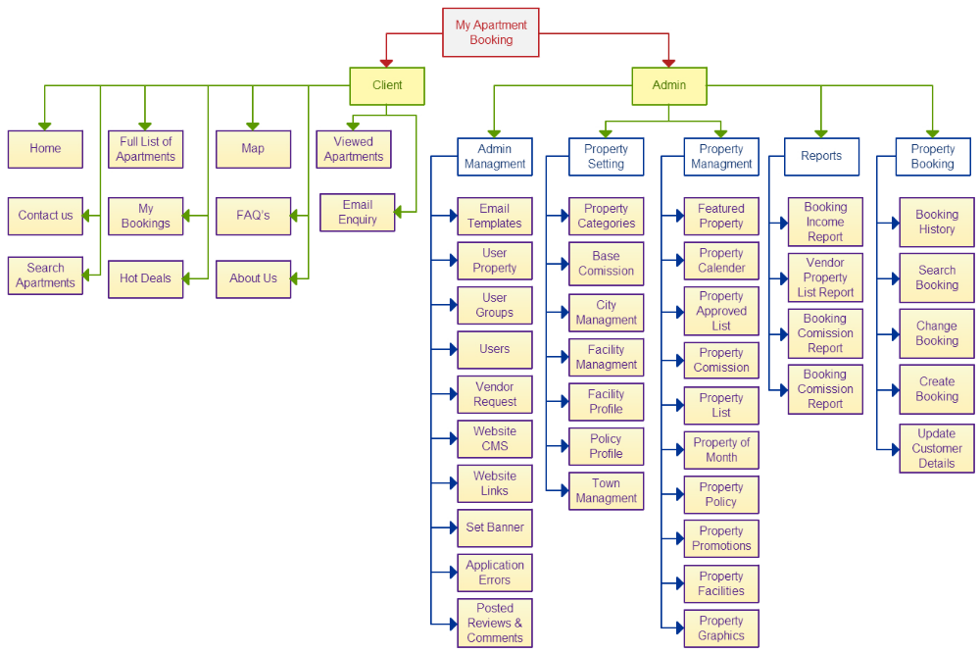

Gantt chart

Refer to Project Schedule

Releases
Will be done when Project Development starts in the Next Phase.

Project Schedule.
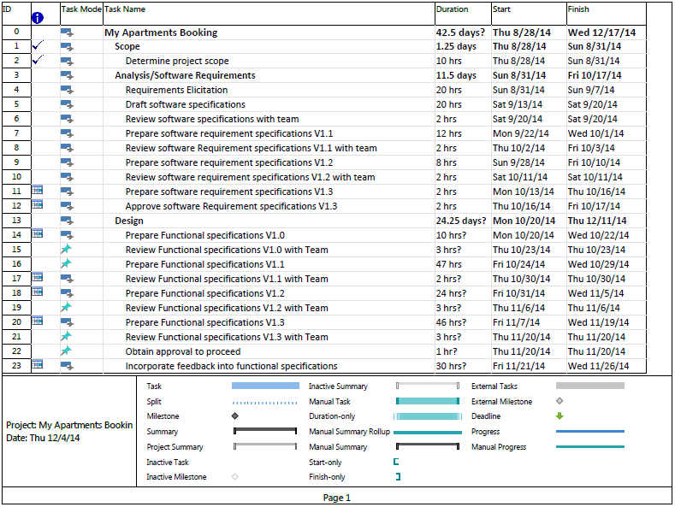

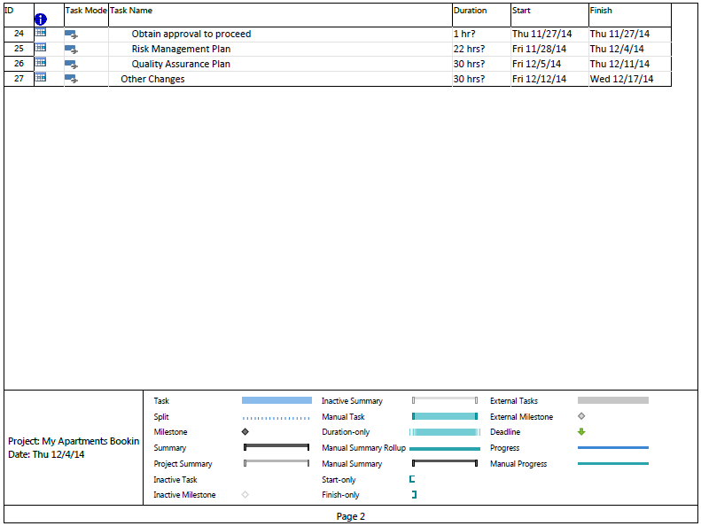

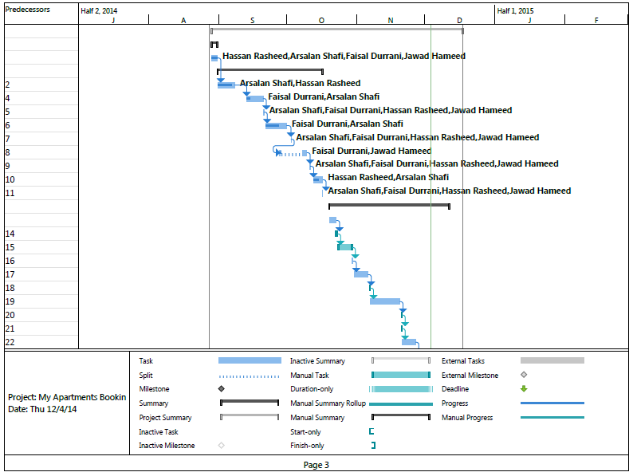

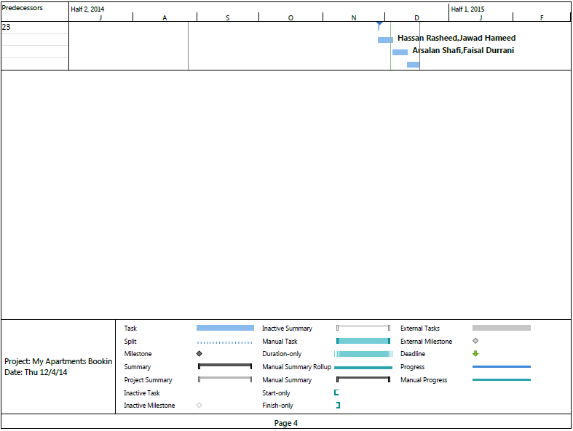

Iteration Plans

Will be done when Project Development starts in the Next Phase.

Team Member’s Training
Training on the following skills will be conducted for the project team prior to the start of implementation activities:

Training | Trainees | Duration
Asp.Net, Telerik Controls ,Sql Server, MS Project, GitHub (For Version Control) | Whole team | 2 weeks
Table A: Training Plan

Further trainings will be done as per need, the duration of other trainings will not exceed 1 week.

Project Monitoring and Control

Requirement Management
All the requirements for My Apartment Booking will be captured in the SRS document. Requested changes to the requirements will be captured in the Change Requests and will be approved as the part of the Configuration Management Process.

Schedule Control Plan
The project manager will maintain a summary schedule showing the expected start and completion dates of each milestone, and is part of the Status Report, as described in the reporting plan. The Status Report will be provided to the client/instructor, who may use this to set new priorities or to recommend corrective action.
Each team member has to provide %completion information of his/her assigned task to project manager two to four times on weekly basis, as per needed or as per priority of the task.
Furthermore, reviews, status meetings, risk identification and mitigation plans (overtime) will be planned.

Quality Control Plan
All the deliverables will go through the appropriate review process to ensure the acceptable quality. Each team member will review the other member’s deliverable, and the PM will do the follow-up to make sure that the deliverable is of acceptable quality. Formal review will be executed by the client, after the PM will approve the deliverable.

Refer to “SQA Plan” document for details.

Reporting Plan
The Status report will be prepared by the Project Manager & Project Team, two to three times per month. This includes:
- Updated schedule estimates
- Quality reports

Risk Management Plan
Refer to “Risk Management Plan” document.

Configuration Management
PM and Configuration Manager will make sure that all the artifacts are included in the specific version.
Refer to the Configuration Management Plan Document.

Communication channels
Following communication channels will be used for communication among the team members.

Formal meeting: PM or any team member will schedule the meeting which have some specific agenda related to the project. Meeting will be schedule based on the availability of the resources. Each meeting will have a facilitator who will lead and manage the meeting and will take the notes.
Email system: All team members share their documents and through an email group.
Voice communication: In case of urgency, cell phone calls will be placed to communicate & update
SMS: SMS will be sent to the team members for the confirmation of the meetings or receiving the email.
Messenger Chat: Skype will be used for online communication

Technical Process Plans

Software Development Lifecycle:
The SDLC used in the My Apartment Booking will be Agile as customer involvement/Feedback is continuously required for delivery of project on time.

Software Design
Each team member will develop the following artifact for the specific module, assigned to him/her for implementation.
- Detailed class diagram along with a detailed description of all attributes, functions or methods specifying interactions between different classes/modules.
- Logical data model (E/R model)
- Physical data models
- Detailed GUIs

Software Development

Software Development Environment
The My Apartment Booking software development will take place at respective suitable places (at home or FAST NU campus), as per need of project team and integration will take place at a common place, as per decision (i.e.at FAST NU or some one’s home).

Each team member must install the following development tools on the system.

Product | Tool(s)
Development | Visual Studio 2010 or Latest, SQL Server 2008 R2, Telerik Tool Kit, PayPal License.
Project Schedule | Microsoft Project
Configuration Management | Tortoise SVN
Documentation | Microsoft Word/Microsoft Excel
Design | Microsoft Visio

Team member and PM will ensure the installation of the development tool.

Development Methods

The software developed will be based on principles of object-oriented approach.

Software Unit Testing

Software Unit Testing Environment

The software unit testing is performed by the developer on the same environment as mentioned in the section 5.5.1 (Software Development Environment).

Software Unit Testing Process
Developer will use the following process in order to perform the unit test:
- Each developer will create a set of test cases for each software component which they developed.
- Each Developer shall write test cases depend upon actual functionality and system flow of the application.
- Define evaluation steps for conducting post-test analysis and comparing actual and expected test results.
- Define and document the test procedures against each module.
- Trace specific test case procedures to requirements allocated to parent test case.
- Visual Studio can be used for Test driven development (Unit Testing).

Review Process
Internal review process will be conducted by the team members at the completion of the each milestone/deliverable, as per need.

Software Integration
After the unit testing of each module that will be developed, the development manager with development team will integrate all the modules.

Software Deployment
Software will be deployed after the successful integration of the software and after the approval of QA.

Project documentation
Currently, all the documents are produced using MS Word, Excel and MS Project. All the documents are placed at central repository GitHub.

